Table of Contents

Evaluate the targeting market and user research 3

1- Who are we? 3

2- which market we are targeting 3

We are ready 9

References: 9

# Evaluate the targeting market and user research

If we want to evaluate the market firstly, what we could do as a creative media production organization and who are we? Secondly, we must now which market we will target

## Who are we?

Hoops is Marketing & Advertising Company you could find us on Istanbul, Beşiktaş or on our website <https://www.hoops.com.tr/en>. Hoops is a 360-degree marketing communication agency that provides the right audience for the brands via identifying the right channels. As creative media production organization we focus on social Media Marketing, advertising, Event Marketing & Planning, UX / UI Design, Web development and Marketing strategy according to (Hoops, 2020).

## which market we are targeting

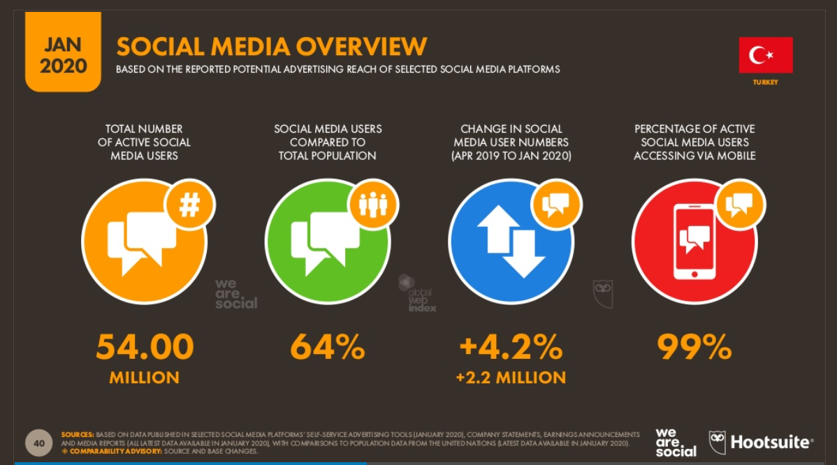We will focus on Turkey market and do a research about which social media we will target. According to (Social, 2020) the total number of active Social media user is 54.00 Million users

Figure 1: Social media overview

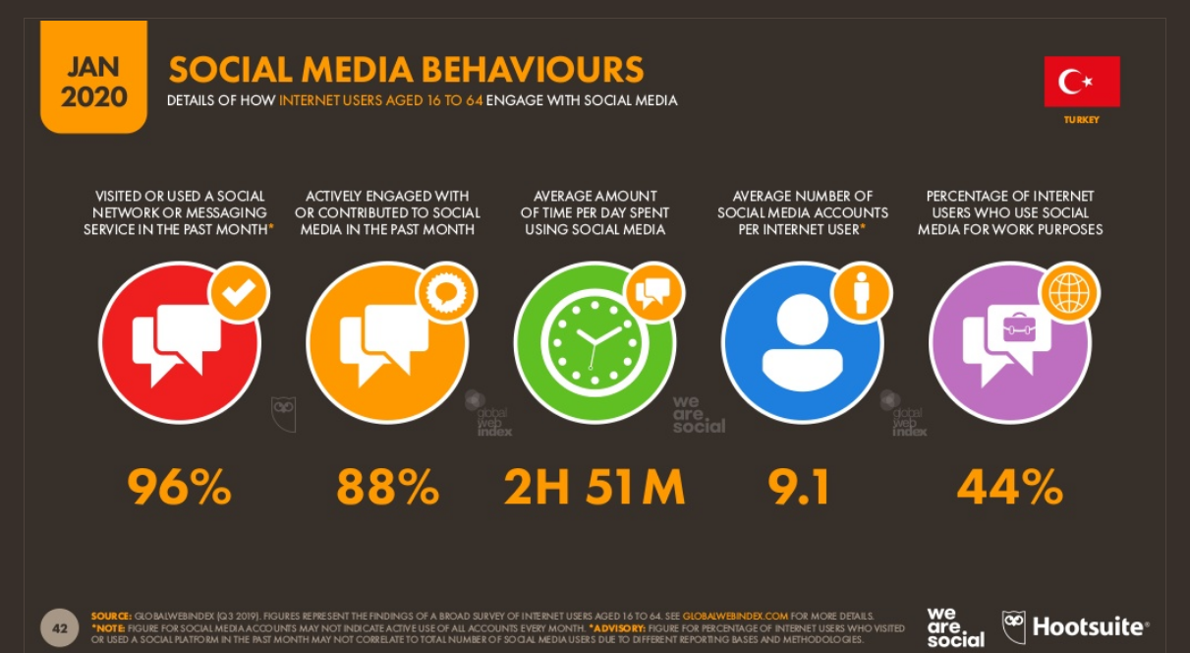Figure 2: Social media behaviors

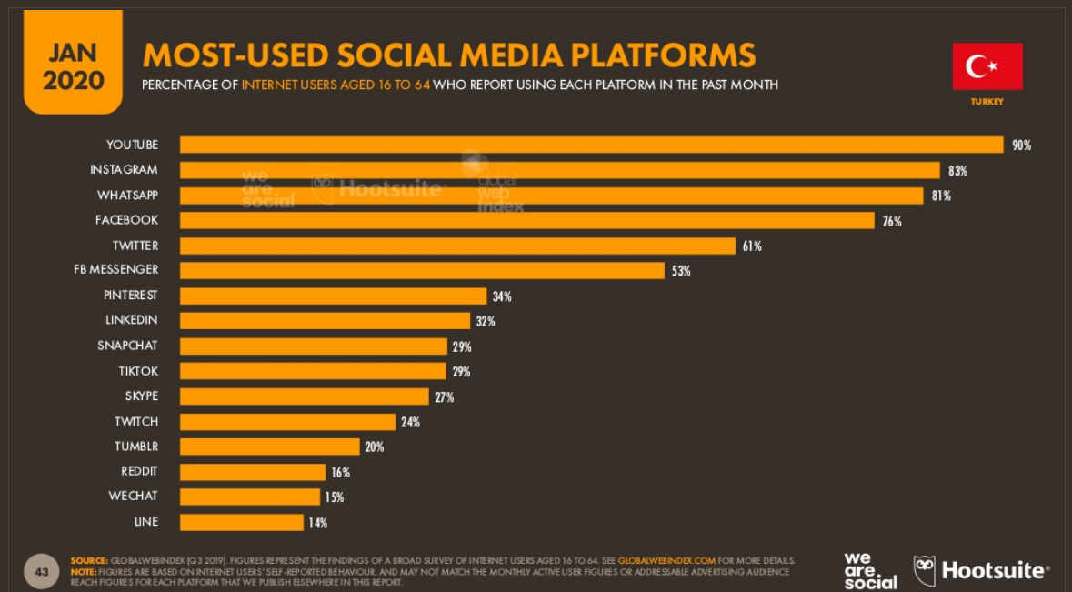If we want to take a look on Social media behaviors, we can see the average of time spent on social media is 2H 51M Its good average.

Figure 3: Most-Used social media platforms in turkey

When developing a social media marketing plan, we should consider these statistics, especially the most used social media sites to meet user needs. these statistics help determine the social media sites that we should focus on and which piece of society we should target. According to our satiation as a creative media production organization we will focus on: Instagram, Facebook and LinkedIn.

1. YouTube
2. Instagram 🡺83% Users of Instagram in Turkey
3. WhatsApp
4. Facebook 🡺 76% Users of Facebook in Turkey
5. Twitter
6. FB Messenger
7. Pineries
8. LinkedIn 🡺 32% Users of LinkedIn in Turkey

After we chose which Social media platforms, we will focus on we must see audience overview for each one

1. 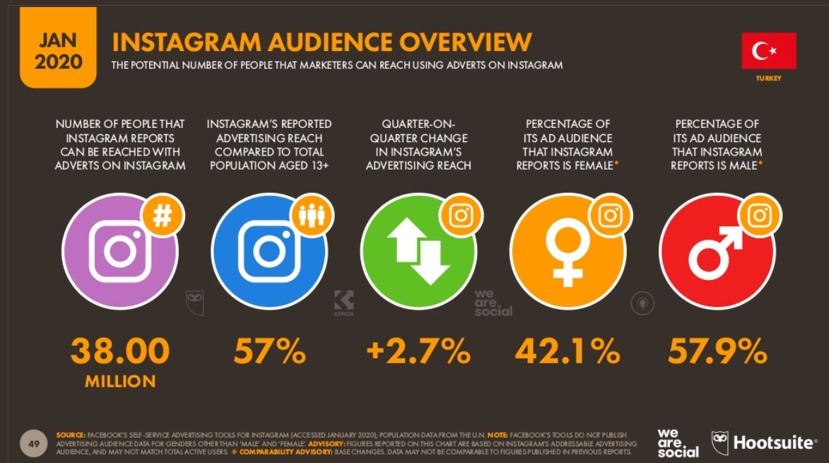Instagram 🡺83% Users of Instagram in Turkey

Figure 4: Instagram audience overview

1. 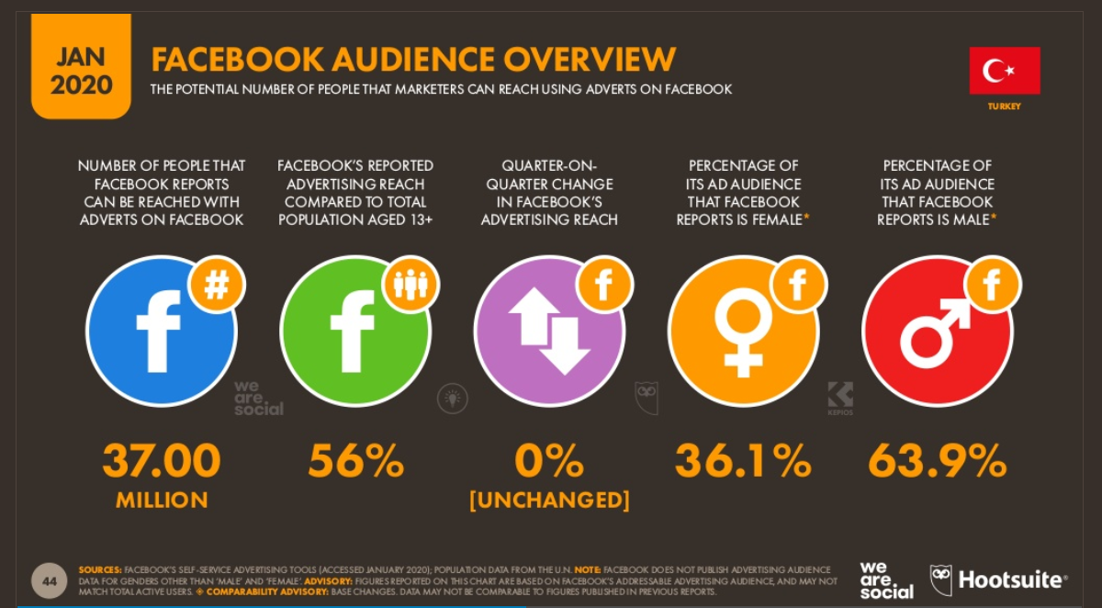Facebook 🡺 76% Users of Facebook in Turkey

Figure 5: Facebook audience overview

1. 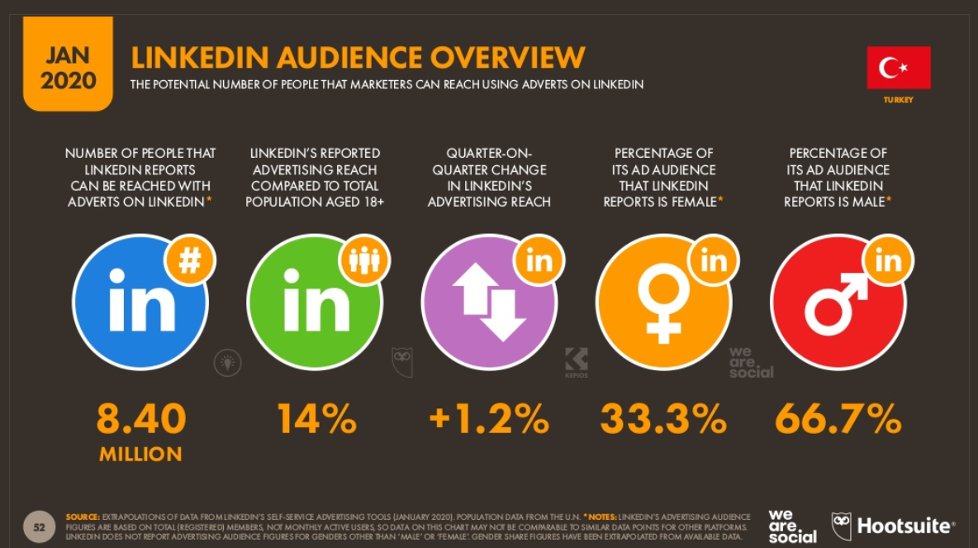LinkedIn 🡺 32% Users of LinkedIn in Turkey

Figure 6: LinkedIn audience overview

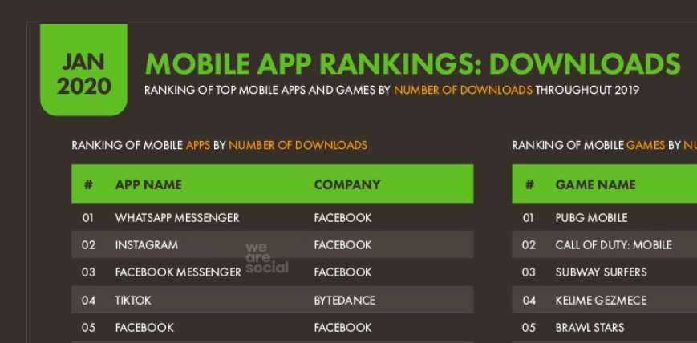 Figure 7: 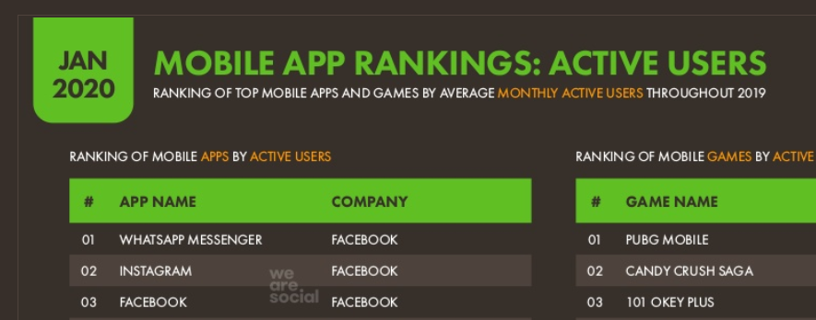Mobile app rank by active user

Figure 8: Mobile app rank by downloads

As we can see in Figure 7, Instagram is the second and Facebook is the third so when we target Instagram and Facebook, we can reach to the largest number of people. And same thing in Figure 8 which analyze ranking by downloads.

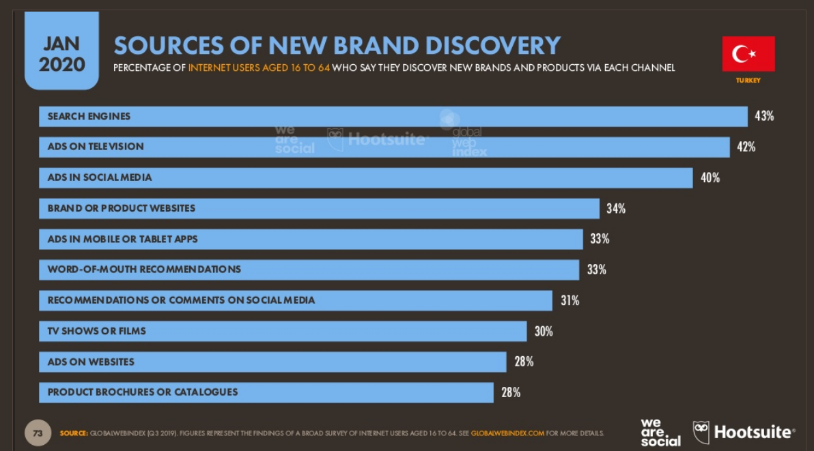After take a look about Statics for each Social media site we chose.Also we should look how Consumers discovers new brands this information will help us to create more creative ways to help our customers to publish their New brands.

Figure 9: look how Consumers discovers new brands

As we see in Figure 9 when we want to help our customers to publish their New brands. we should focus on these ways to be more creative and to get customers satisfaction.

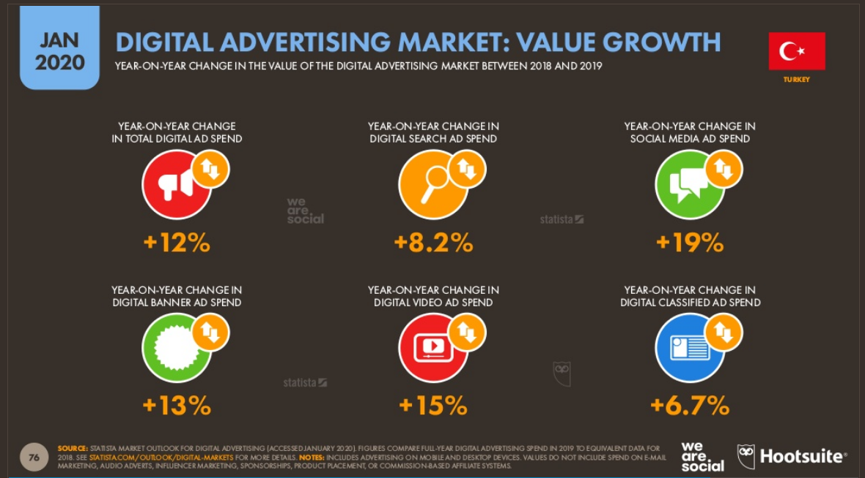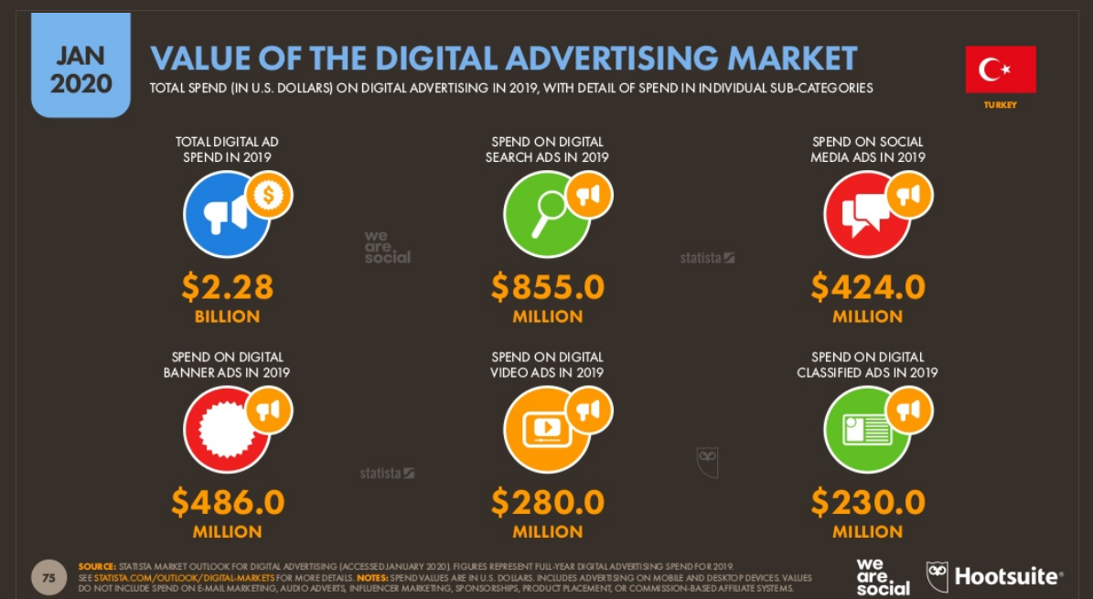Figure 10: Value of the digital advertising

Figure 11: Growth of digital advertising market

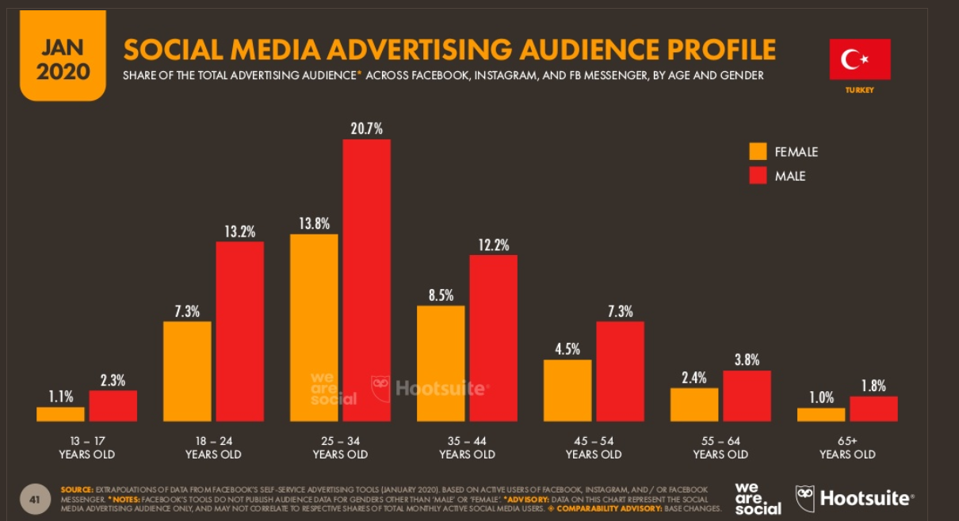After we saw the Figure 10 and Figure 11, we had a clear picture of the value of ads in the Turkish market, so when looking at the Figure 10 we can see the huge expenses that were spent on the ads and this will help us in setting the budget for the marketing plan. As for the Figure 11 we can see the size of the e-marketing growth and this indicates that it an excellent environment to work on it.

Figure 12:Social media advertising audience profile

According to Figure 12 the social media advertising audiences start from 13 to +65. But we as creative media production organization will target the people from 25 to 54 from male & Female.

# We are ready

After analyze or required information’s and evaluate the Turkish market and user research we could say that now we are read to create our plan.

# References:

Hoops, c., 2020. Hoops Client Reviews | Clutch.Co. [online] Clutch.co. Available at: <https://clutch.co/profile/hoops> [Accessed 30 June 2020].

Social, W., 2020. Digital 2020: Turkey — Datareportal – Global Digital Insights. [online] DataReportal – Global Digital Insights. Available at: <https://datareportal.com/reports/digital-2020-turkey> [Accessed 30 June 2020].